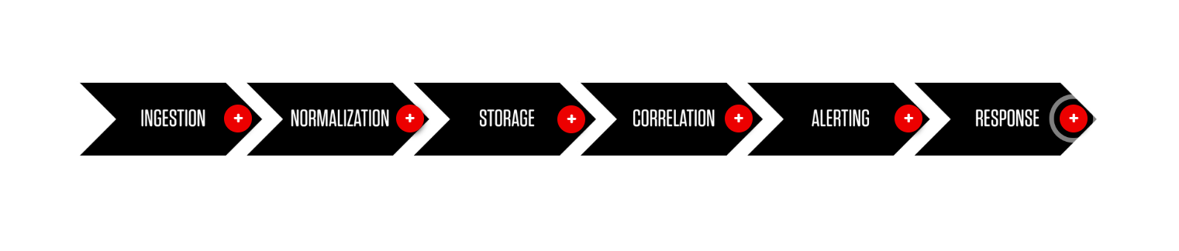

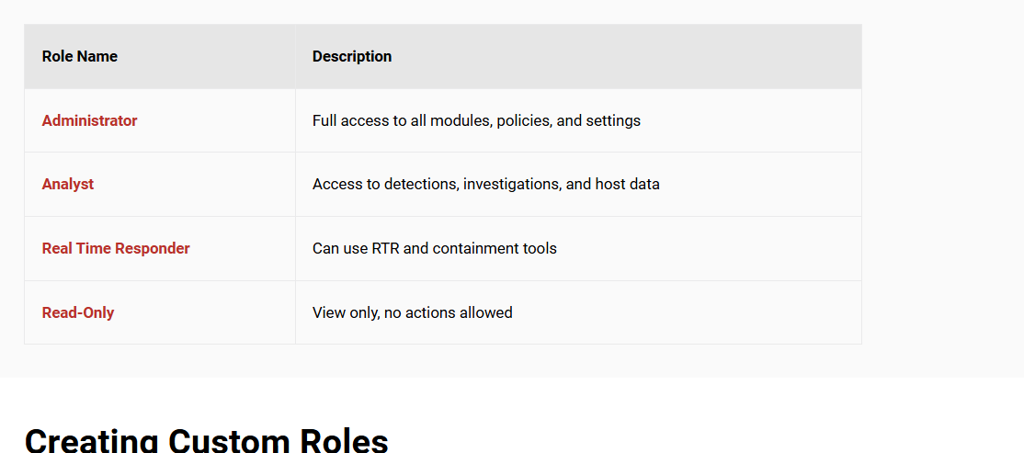

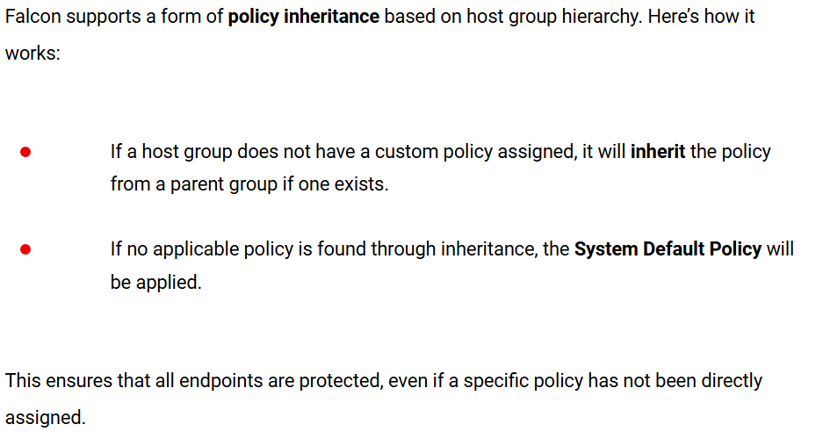

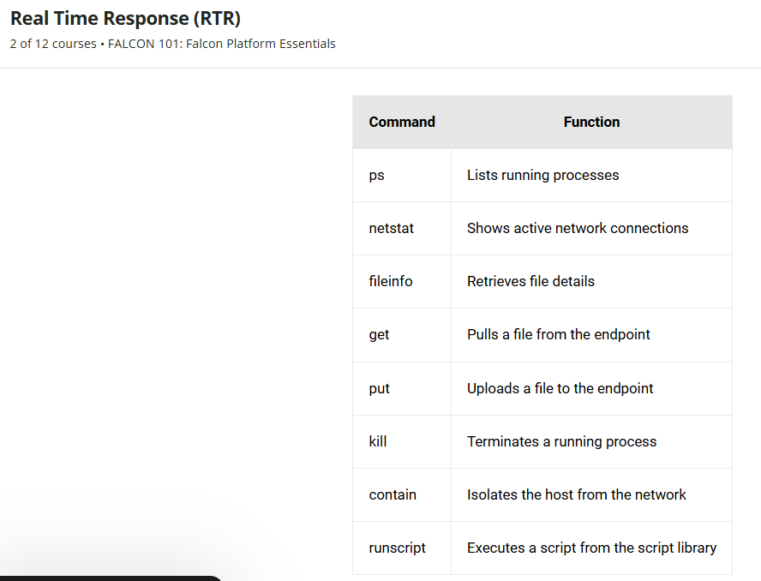

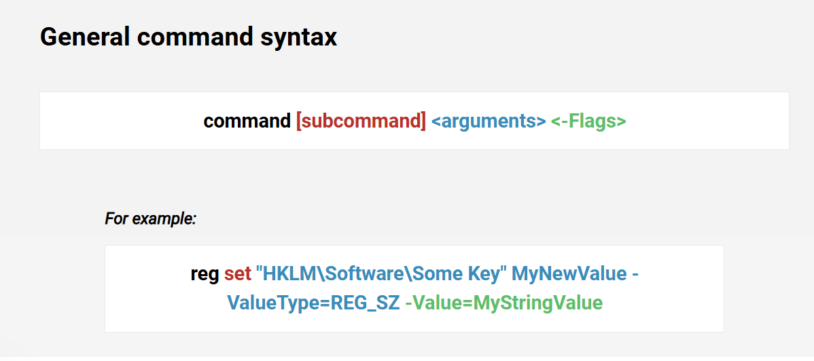

* **Dashboards and Analytics Drive Proactive Defense -**Customizable dashboards visualize detection trends, risk areas, sensor health, and compliance. Teams can track progress, prioritize threats, and align operations with business or security objectives.
* **Unified Console for Security Operations -**The Falcon platform integrates endpoint, identity, cloud, and SIEM capabilities into a single, role-aware console. This streamlines investigation, monitoring, configuration, and response workflows for different security roles—from SOC analysts to IT admins.
* **Role-Based Host and User Management -**Hosts are grouped dynamically or statically for policy application and visibility. Role-based access control (RBAC) ensures that users only access the tools and data relevant to their responsibilities, enhancing both security and compliance.
* **Real-Time Endpoint Protection -**Falcon’s Endpoint Security uses a lightweight sensor combined with cloud intelligence to detect threats via IOAs, behavioral analytics, and machine learning. Prevention policies and exclusions help fine-tune detections while maintaining protection.
* **Identity is the New Perimeter -**Identity Protection continuously monitors Active Directory for threats like lateral movement, stolen credentials, and privilege escalation. It flags risky accounts, misconfigurations, and abnormal behaviors, and is tightly integrated with Next-Gen SIEM for holistic analysis.
* **Real Time Response (RTR) for Live Remediation -**RTR enables analysts to remotely connect to endpoints, run commands, collect forensic data, and take immediate action (e.g., terminate processes, contain hosts). It’s a critical tool for reducing dwell time and accelerating incident response.
* **Threat Intelligence with Adversary Context -**Falcon’s Threat Intelligence module enriches detections with insights about adversary motivations, tactics, and campaign histories. This helps teams anticipate attacker behavior and tailor defense strategies accordingly.
* **Charlotte AI for Natural Language Investigation -**Charlotte AI empowers analysts of all skill levels to investigate threats using plain language questions. It provides context-aware insights, links to MITRE tactics, and pulls data across Falcon modules—reducing the complexity of threat triage.
* **PromptBooks for Scalable, Guided Investigations -**PromptBooks in Charlotte AI offer repeatable workflows for incident triage, threat hunting, and onboarding. They help ensure consistency and speed by automating multi-step investigations with minimal effort.

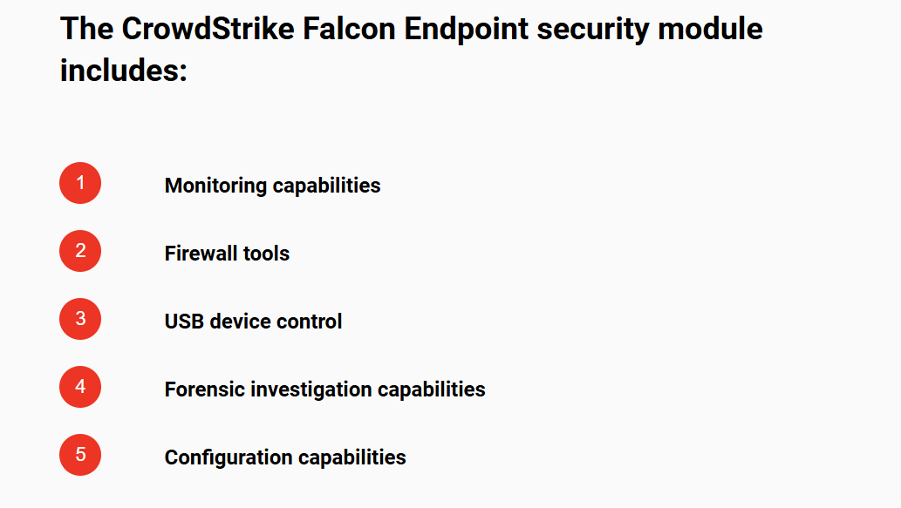

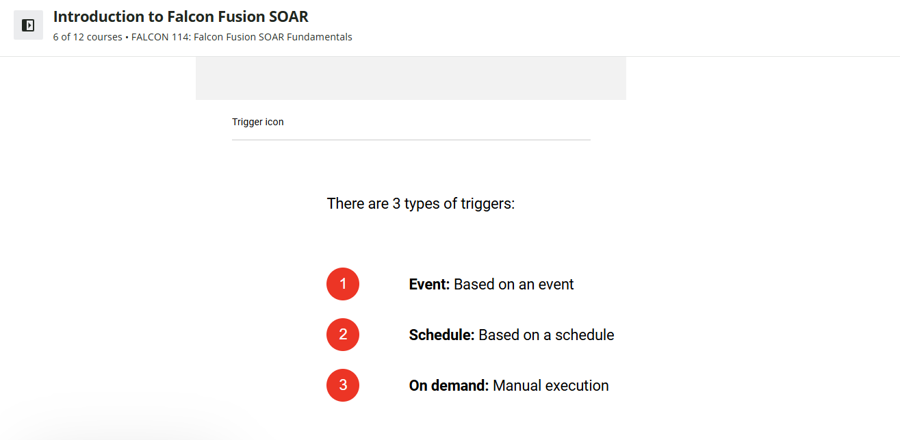

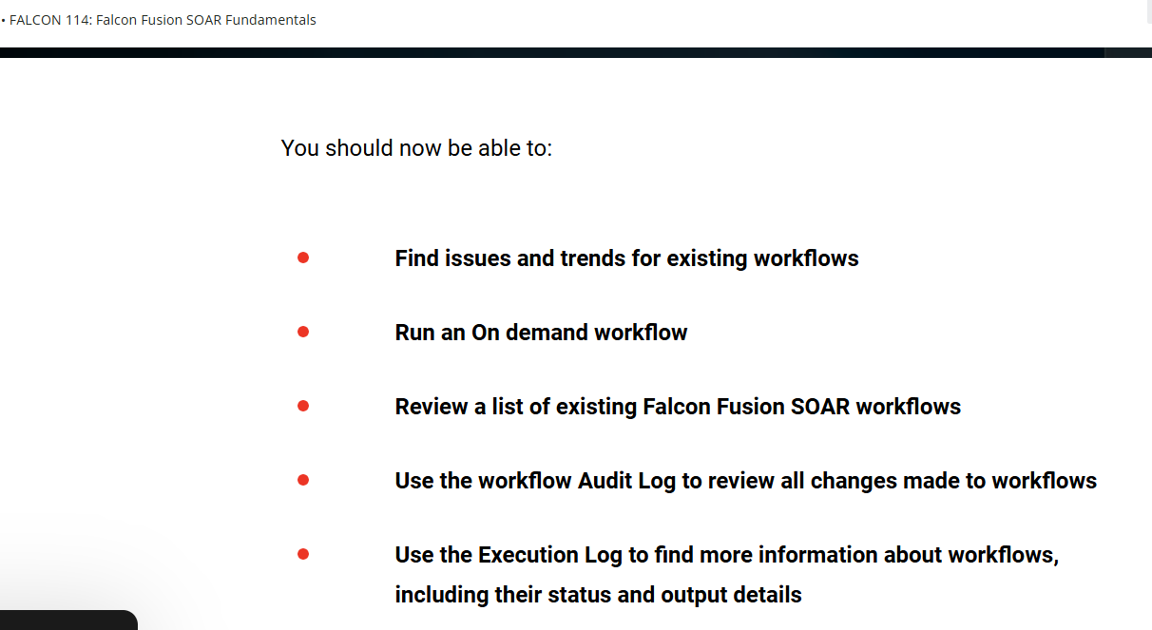

* **Build a basic workflow**
* **Edit an existing workflow**
* **Add sequential and parallel conditions and actions to a workflow**
* **Add CrowdStore integrations to a workflow**
* **Add loops to workflows**
* **Add Else, if conditions and Else actions and loops to a workflow**
* **Configure an action's input and output using the form-based schema builder**
* **Configure an On demand trigger using the schema builder**

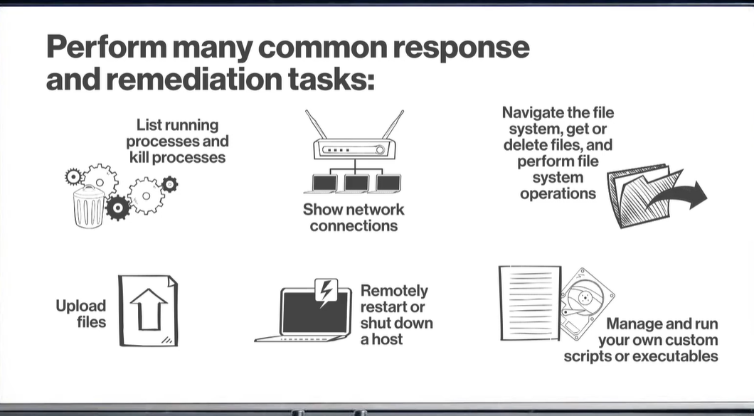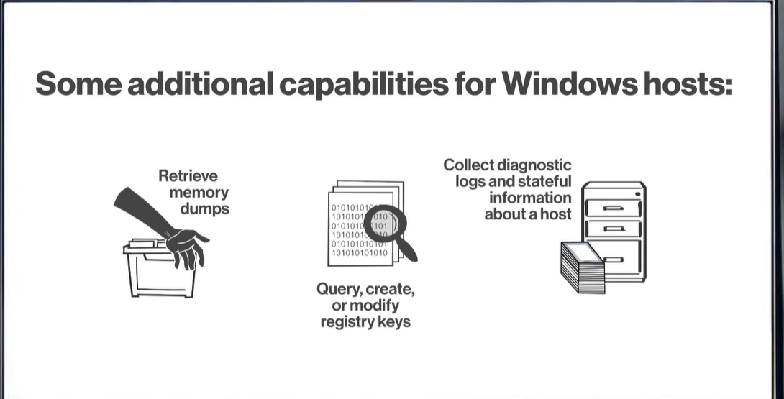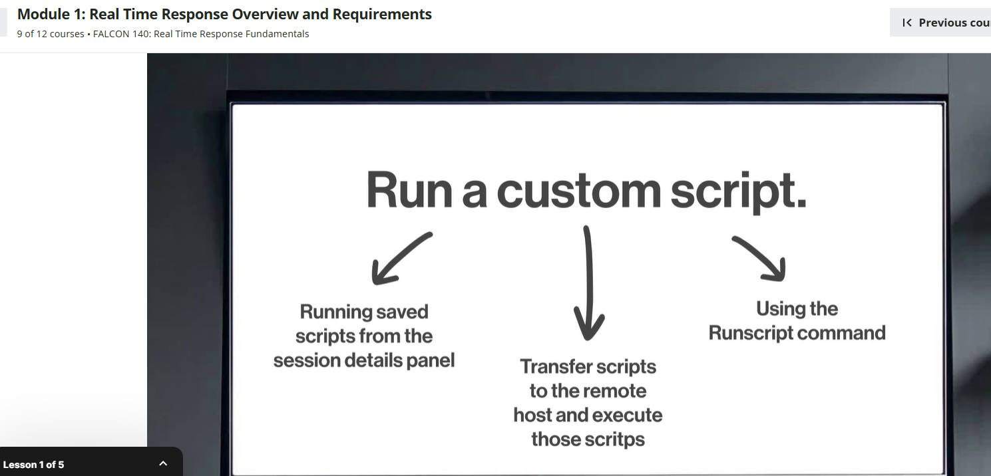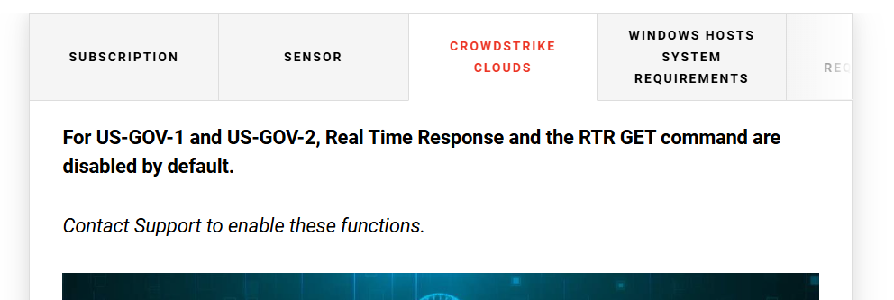

**Falcon has three Real Time Responder roles to grant users access to different sets of commands to run on hosts.**

**Real Time Response - Read Only Analyst**

This role can run a core set of read-only response commands **to perform reconnaissance and triage**.

**Real Time Responder - Active Responder**

This role can run all of the commands **RTR Read Only Analyst**can and more, including:

* **Extract files using the get command**
* **Run commands that modify the state of the remote host**
* **Run certain custom scripts**

**Real Time Responder - Administrator**

This role can do everything **RTR Active Responder** can do, plus:

* **Create custom scripts**
* **Upload files to hosts using the put command**
* **Directly run executables using the run command**

**Real Time Responder - Administrator**

**This role can do everything RTR Active Responder can do, plus:**

* **Create custom scripts**
* **Upload files to hosts using the put command**
* **Directly run executables using the run command**

**Real Time Response commands & user role permissions**

***Review the table below to learn more about which commands each RTR role can run.***

| **Command** | **RTR Read Only Analyst** | **RTR Active Responder** | **RTR Administrator** |
| --- | --- | --- | --- |
| **cat** | **YES** | **YES** | **YES** |
| **cd** | **YES** | **YES** | **YES** |
| **clear** | **YES** | **YES** | **YES** |
| **cp** | **NO** | **YES** | **YES** |
| **csrutil** | **YES** | **YES** | **YES** |
| **cswindiag** | **NO** | **NO** | **YES** |
| **encrypt** | **NO** | **YES** | **YES** |
| **env** | **YES** | **YES** | **YES** |
| **eventlog** | **YES** | **YES** | **YES** |
| **falconscript** | **NO** | **NO** | **YES** |
| **filehash** | **YES** | **YES** | **YES** |
| **get** | **NO** | **YES** | **YES** |
| **getsid** | **YES** | **YES** | **YES** |
| **help** | **YES** | **YES** | **YES** |
| **history** | **YES** | **YES** | **YES** |
| **ipconfig** | **YES** | **YES** | **YES** |
| **ipconfig** | **YES** | **YES** | **YES** |
| **kill** | **NO** | **YES** | **YES** |
| **ls** | **YES** | **YES** | **YES** |
| **map** | **NO** | **YES** | **YES** |
| **memdump** | **NO** | **YES** | **YES** |
| **mkdir** | **NO** | **YES** | **YES** |
| **mount** | **YES** | **YES** | **YES** |
| **mv** | **NO** | **YES** | **YES** |
| **netstat** | **YES** | **YES** | **YES** |
| **ps** | **YES** | **YES** | **YES** |
| **put** | **NO** | **NO** | **YES** |
| **put-and-run** | **NO** | **NO** | **YES** |
| **reg query** | **YES** | **YES** | **YES** |
| **reg set** | **NO** | **YES** | **YES** |
| **reg delete** | **NO** | **YES** | **YES** |
| **reg load** | **NO** | **YES** | **YES** |
| **reg unload** | **NO** | **YES** | **YES** |
| **restart** | **NO** | **YES** | **YES** |
| **rm** | **NO** | **YES** | **YES** |
| **run** | **NO** | **NO** | **YES** |
| **runscript** | **NO** | **YES** | **YES** |
| **shutdown** | **NO** | **YES** | **YES** |
| **tar** | **NO** | **YES** | **YES** |
| **unmount** | **NO** | **YES** | **YES** |
| **unmap** | **NO** | **YES** | **YES** |
| **update** | **NO** | **YES** | **YES** |
| **users** | **YES** | **YES** | **YES** |
| **xmemdump** | **NO** | **YES** | **YES** |
| **zip** | **NO** | **YES** | **YES** |

**With their time-based one-time password (TOTP), users are required to enter a 6-digit code that’s generated by an authentication app on their mobile device before they’re allowed to perform an MFA-enforced operation.**

**Continued**

**Account configuration**

**Falcon MFA for RTR is enabled and configured for all users in your organization from the General settings page.**

**From this page you can choose when and how often users are prompted to verify their identity.**

**1 Navigate to the General Settings page.  
*Select each numbered button below to learn how to find the General settings page.***

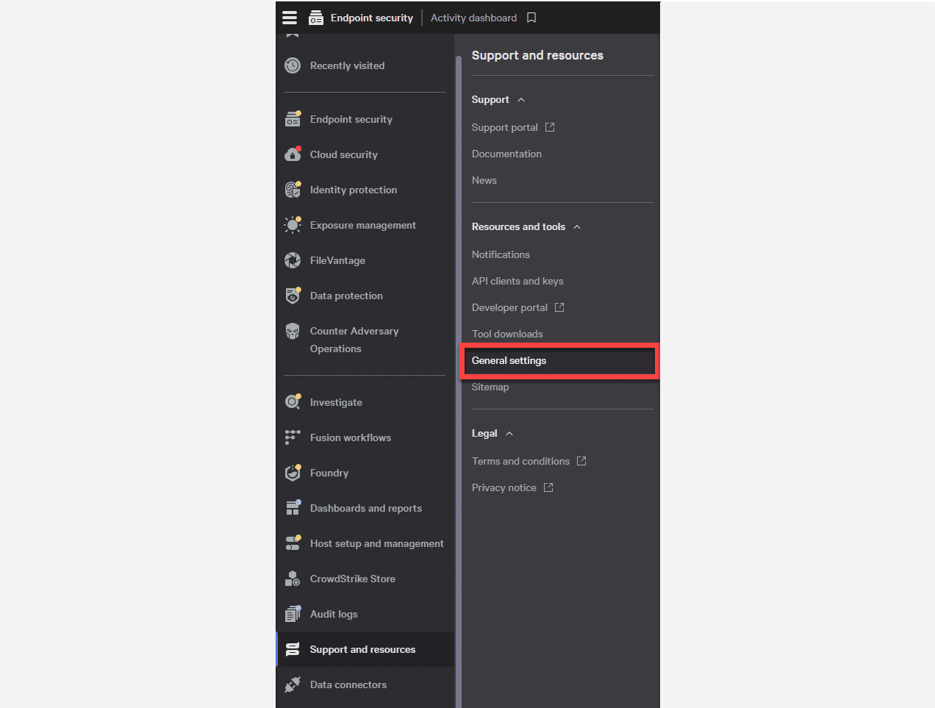

**Continued**

**2**

**On the General settings page, scroll down to the Real Time Response identity verification section and enable the Initiate Falcon MFA identity verification before running a 'run' or 'kill' command or connecting to a host toggle button.**

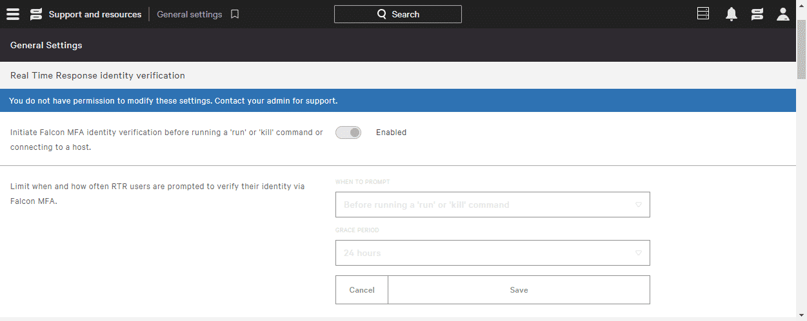

**General settings page showing the Real Time Response identity verification section**

**3**

**Click the WHEN TO PROMPT dropdown and select one of two RTR triggers.**

**Before connecting to hosts  
2. Before running a 'run' or 'kill' command**

***This tells Falcon MFA for RTR when to prompt a user.***

**4**

**Click the GRACE PERIOD dropdown to set how long a user can perform the MFA-enforced actions without being prompted again for authentication.**

***When the grace period expires, the user will be prompted to reauthenticate with a TOTP code.***

**5**

**Click Save.**

**User configuration**

**If your CID uses single sign on (SSO) for Falcon login, individual users must also:**

**1**

**Install a TOTP authentication app on their mobile device.**

**2**

**Set up an MFA profile specifically for RTR access using a QR code that Falcon provides.**

**Note: Users that log in with Falcon MFA have already completed this process.**

**IMPORTANT: Falcon MFA for RTR is supported on most authentication apps that comply with the TOTP standard, such as Google Authenticator and Microsoft Authenticator.**

**Configure user**

**If your CID uses single sign on (SSO) for Falcon login, individual users must also:**

**1**

**Install a TOTP authentication app on the user's mobile device.**

**2**

**Set up an MFA profile specifically for RTR access using a QR code that Falcon provides.**

**High-risk command configuration**



**In addition to identity verification,   
Falcon MFA for RTR requires user confirmation when attempting to   
issue kill or run commands in the   
RTR console.**

**Note: Falcon MFA for RTR is not supported through the CrowdStrike API or when running RTR commands via Falcon Fusion workflows.**

* **Falcon Administrators can enable and configure Falcon MFA for RTR.**
* **Accounts must use Falcon MFA or a 3rd-party SSO for Falcon console login.**
* **Falcon MFA for RTR requires use of a TOTP authentication application, such as Google Authenticator or Microsoft Authenticator.**
* **Falcon MFA for RTR is enabled and managed independently by each CID in a Falcon Flight Control environment.**
* **For users with multi-CID access, Falcon MFA for RTR enforcement in CIDs other than a user’s home CID requires both the home CID and the additional CID to use Falcon MFA or a third-party SSO for Falcon console login.**

**For specific steps to enable and configure Falcon MFA for RTR, access the support documentation in Falcon by navigating to Support and resources > Support > Documentation.**

**Once in the support documentation, navigate to Endpoint security > Response > Real Time Response and Network Containment.**

1. **Navigate to Host setup and management > Response and containment > Response policies.**
2. **Click Create policy.**
3. **In the Create response policy dialog, enter a Policy name.**
4. **Verify that the Platform is set appropriately.**
5. **Enter a Description.**
6. **Click Create policy.**
7. **Enable or disable individual response policy settings on the Policy details page.  
     
   The Real Time Response setting is required to be toggled on in order to perform any Real Time Response actions on hosts.   
     
   Click the Real Time Response checkbox to enable Real Time Response.**
8. **The Custom Scripts setting controls whether users with RTR Active Responder or RTR Administrator can run custom scripts.   
     
   Click the Custom Scripts checkbox to enable the use of custom scripts.**
9. **If you also want to enable Falcon Scripts, you can check that separately to enable.   
     
   Click the Falcon Scripts checkbox.**
10. **The settings in the High risk commands section control availability of a collection of commands that have a higher potential to cause problems if improperly executed.   
      
    Click the checkboxes next to each of the high risk commands.**
11. **Click Save.**
12. **Review your policy changes and click Save.**

**To assign a host group to a response policy:**

1. **Navigate to Host setup and management > Response and containment > Response policies.**
2. **Click the name of the policy you want to edit.**
3. **From a Response policy’s settings page, click the Assigned host groups tab.**
4. **Click Add groups to policy.**
5. **In the Add Groups to Policy dialog, select one or more groups.**
6. **Click Add groups to policy.**

**To enable a response policy:**

1. **From a Response policy's settings page, click Enable policy.**

**The CrowdStrike cloud can generally handle scripts up to 40KB, however, the actual limits you encounter might be higher or lower.**

* **Script sizes are constrained by the underlying messaging architecture that Real Time Response uses.**
* **Because scripts are saved in encoded format and carry some additional overhead, we can’t pinpoint an exact size guideline.**

**To work around script size limitations, run the script directly from the remote host’s file system. Use the put command to load the script onto the remote host, then use runscript with the -HostPath flag to run the script.**

**Now that we know the basic UI of the Incident Workbench, let’s take a magnifying glass to the incident graph to learn more.**

**Continued**

**The incident graph is made up of nodes and links. The nodes, depicted by icons, represent a wide variety of indicators that help analysts gather a lot of information at a glance.**

**Expand the accordion below to learn more about each of the icons represented on the Incident graph.**

**Endpoint Indicator**

**Any process directly related to individual endpoints within an environment.**

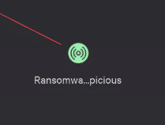

**Host**

**Device that is connected to a network and can communicate with other hosts.**

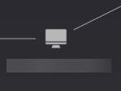

**Process Activities**

**The activity or interaction between endpoints and processes.**

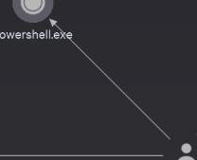

**Processes**

**A file that can be found on endpoint devices.**

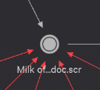

**Users**

**Accounts associated to individuals with account access in an environment.**

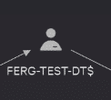

**Hash**

**Function that turns data into non-descript text to keep sensitive information and data secure.**

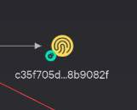

**C**

**Incident Workbench Remediation Tools**

**The sidebar menu is made up of ten remediation tools.**

**Expand the accordion below to learn more about the capabilities of all the tools within the Incident Workbench.**

**Legend**

**Provides a list of the all entities currently present in the graph broken up into the node categories. Clicking on the eye symbols allows users to hide or reveal entities on the graph.**

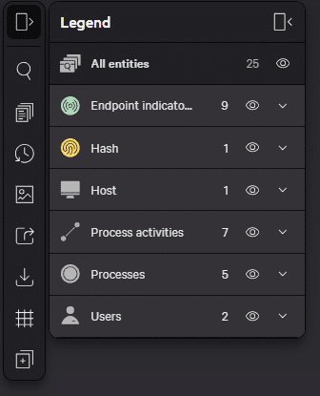

**Search on graph**

**Use to search for specific entities or nodes present on the incident graph.**

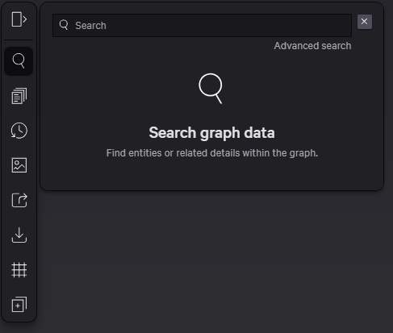

**Incident Notes**

**Add notes for the incident or certain entities. Visible to all collaborators and has a tagging function to tag other analysts.**

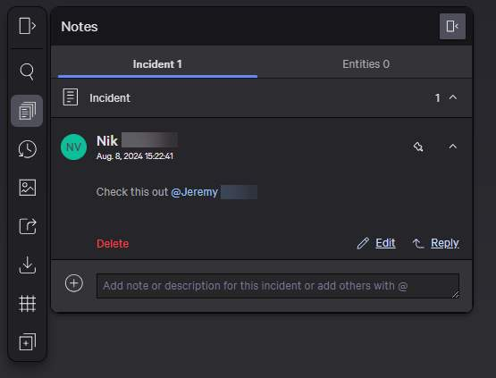

**History**

**A timeline of all incident graph versions including the current version. Allows analysts to revert the graph back to previous versions.**

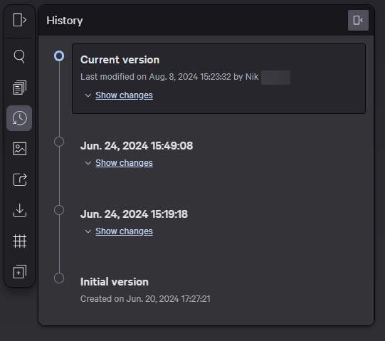

**Download PNG**

**Exports a PNG file of the incident graph.**

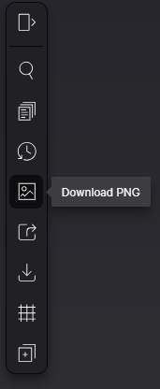

**Download PDF**

**Exports a PDF file of the incident graph. Users can edit what is included on the export such as the graph, status log, workbench notes, and the timeline.**

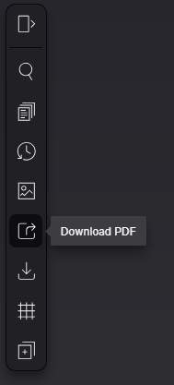

**Download JSON**

**Exports a JSON file of the incident graph.**

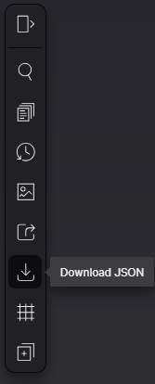

**Auto-adjust Graph**

**Cleans up the appearance of the graph nodes using one of three methods:**

* **Adjust all graph nodes with Adjust all**
* **Manually move nodes around, and then adjust only unchanged nodes with Adjust unchanged**
* **Adjust only selected nodes with Adjust selected**

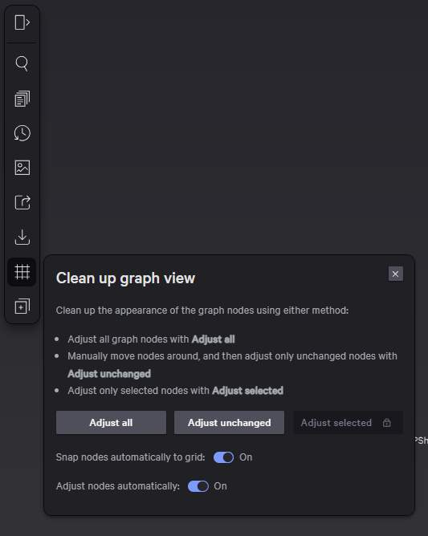

**Enrichments**

**Allows users to add a data enrichment to selected nodes**

* **Files and URLs use Sandbox to enrich**
* **URL, Malware, and IOCs can get Intel info for anything from malware family to threat actors and reports**

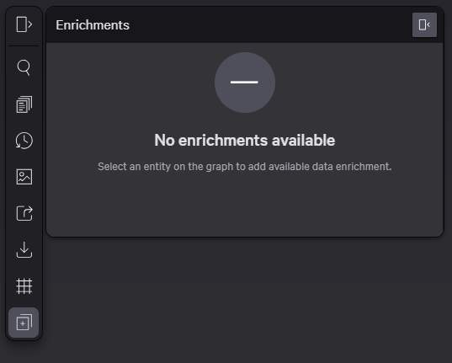

**As you can see, the Incident Workbench provides analysts with a ton of valuable and relevant information, as well as helpful tools to quickly and efficiently remediate and solve incidents within the Falcon console.**

**FALCON ADMINISTRATOR**

**For access, need falconadministrator role + RTR role**

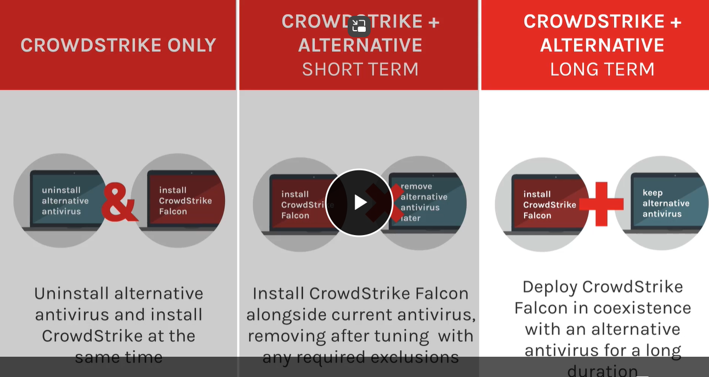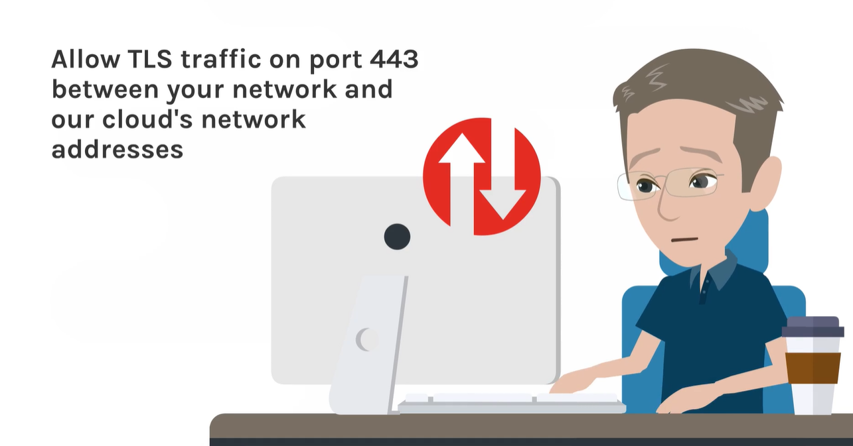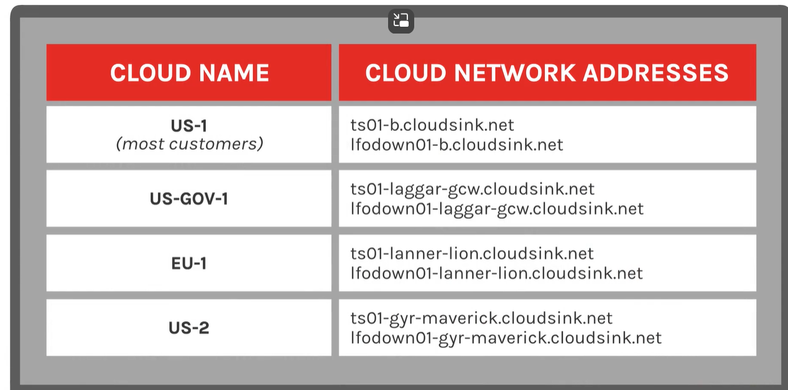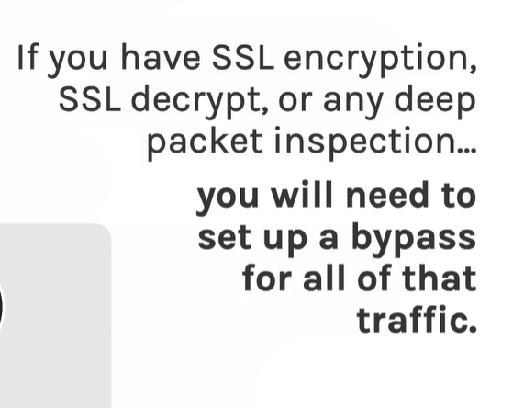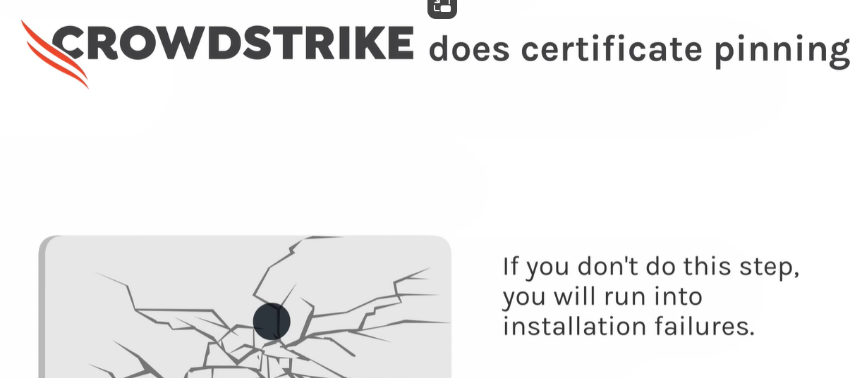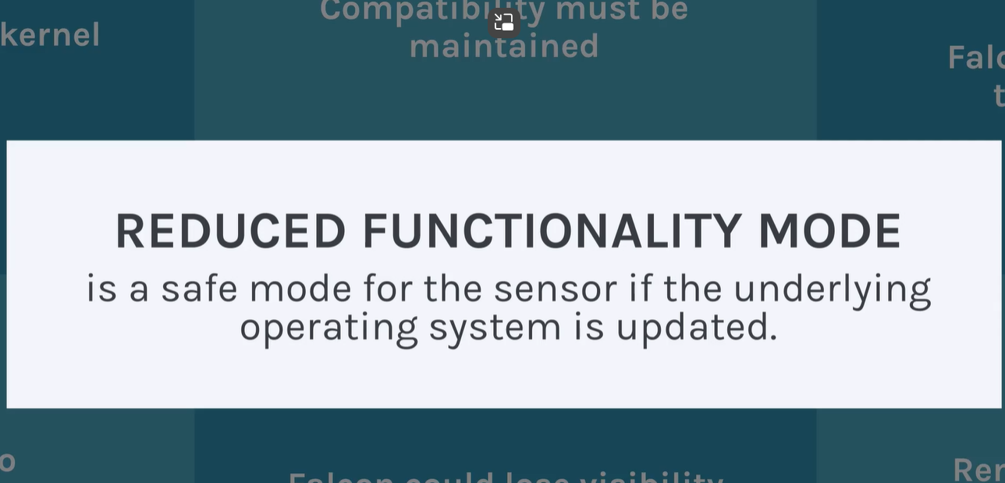

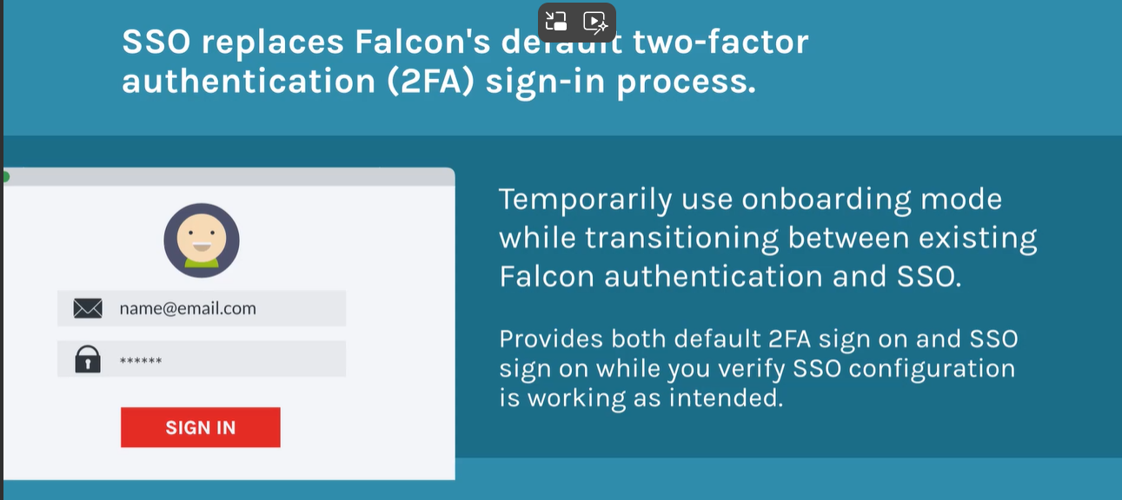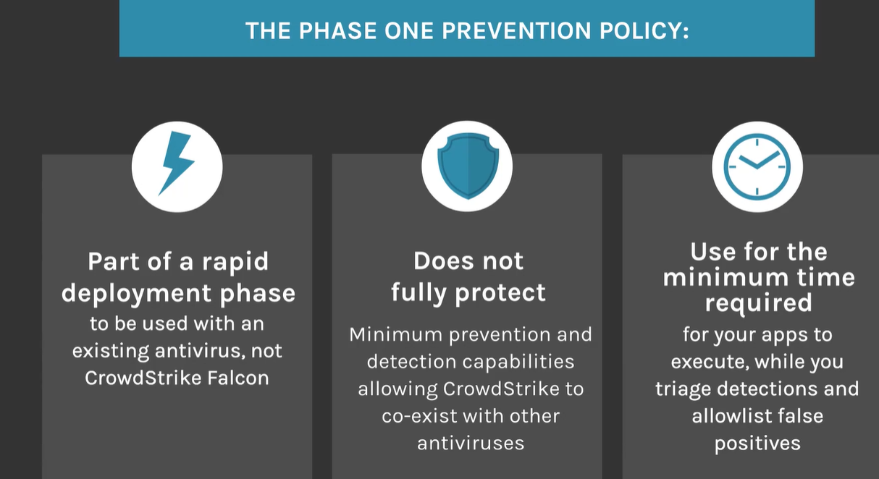

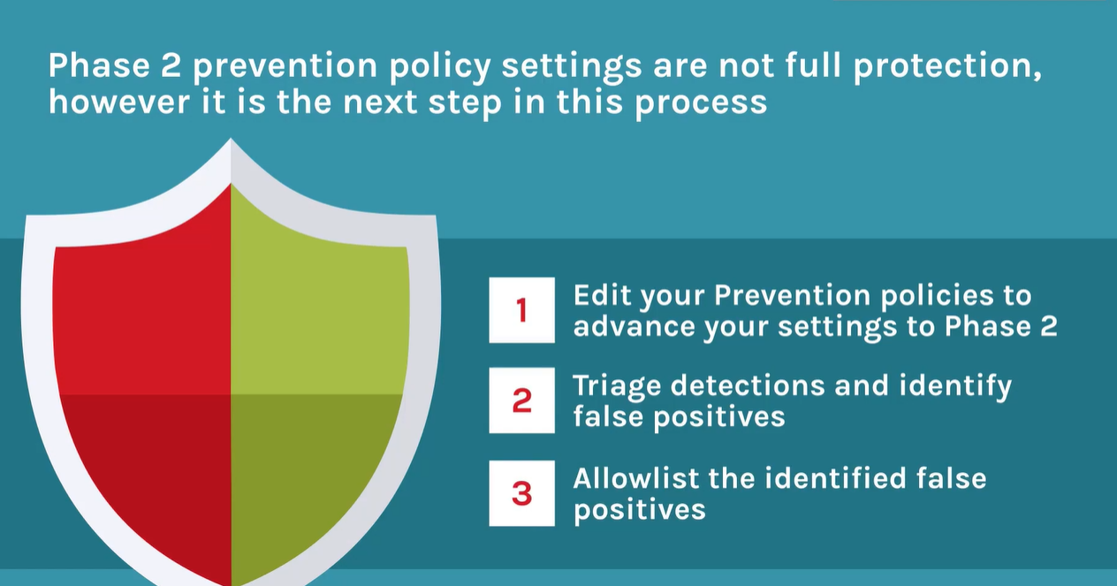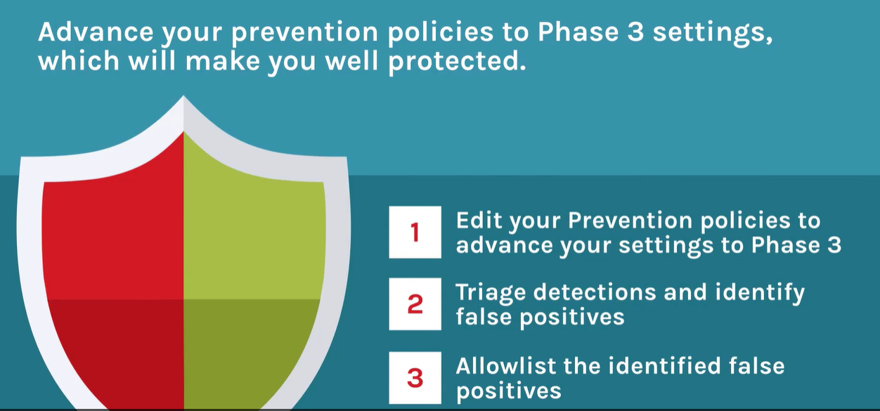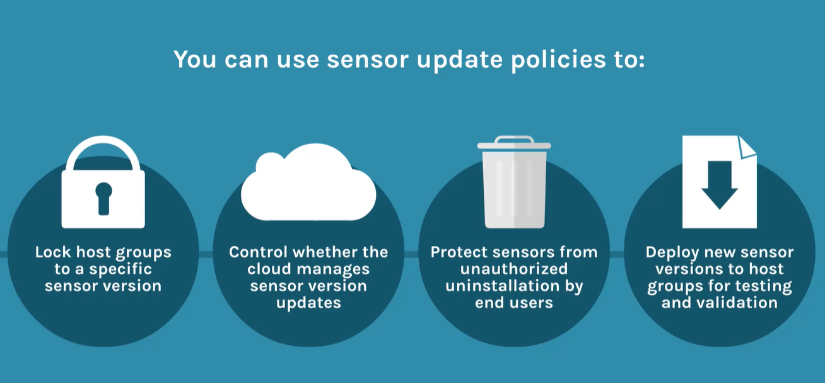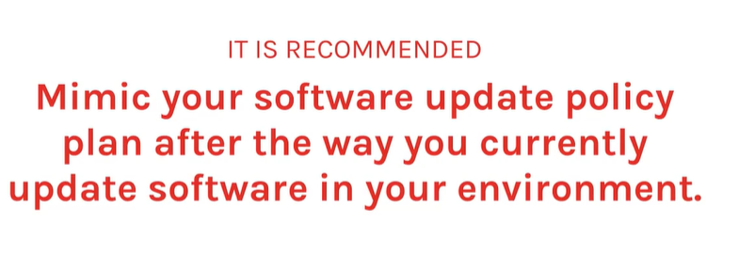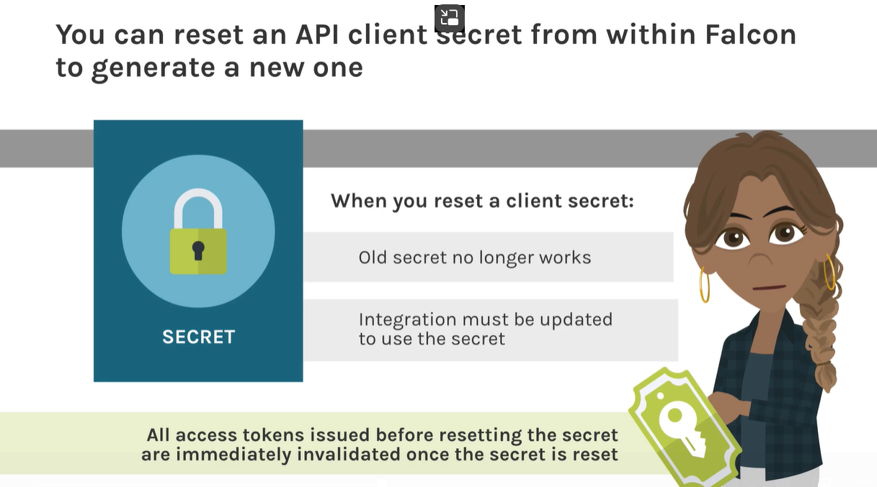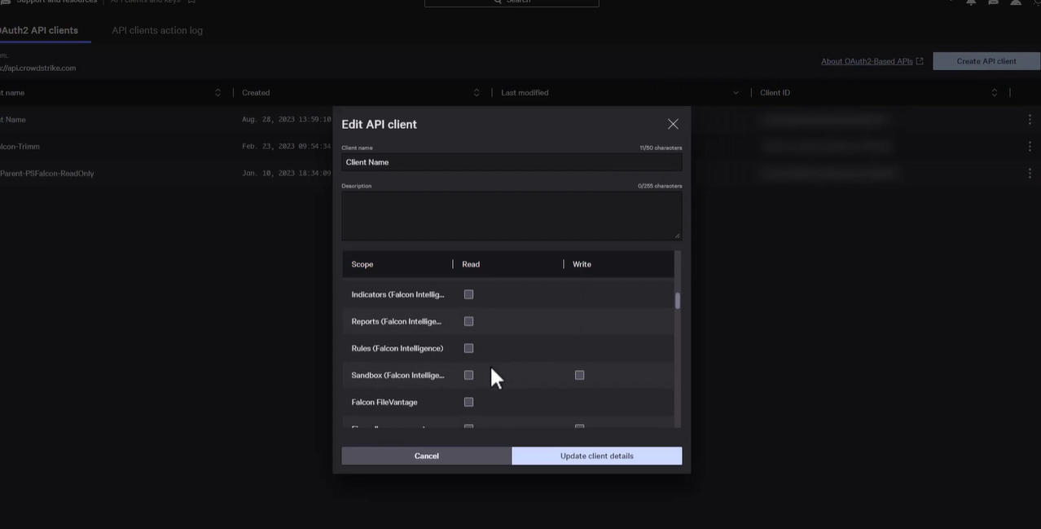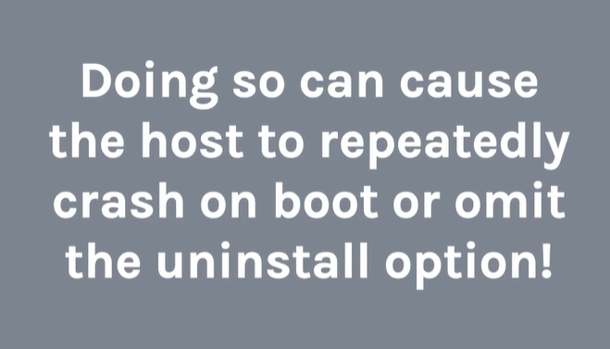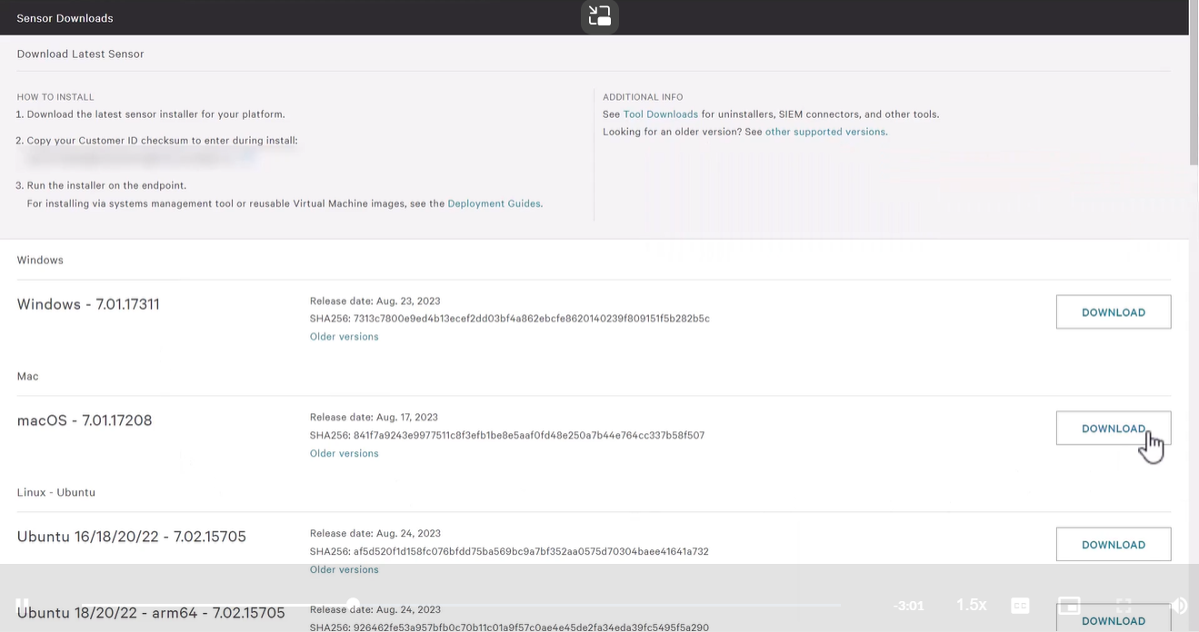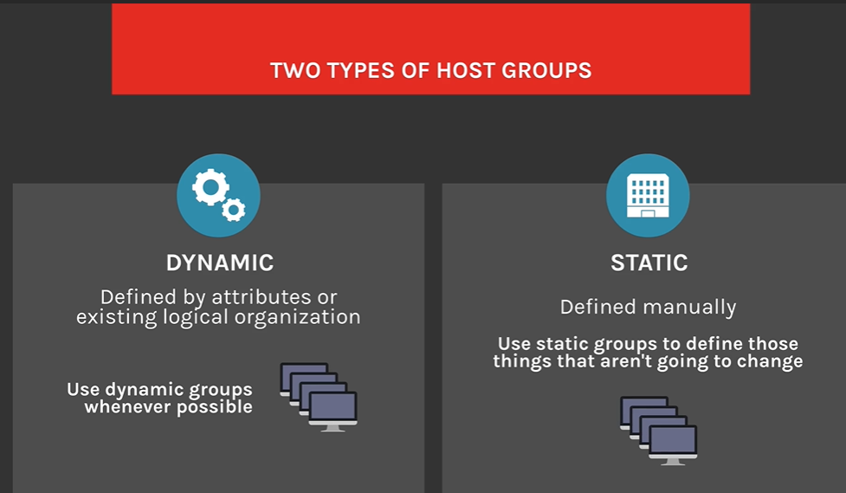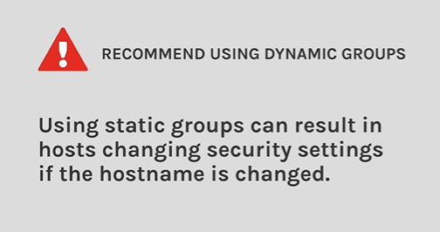

**Assign host groups to policies**

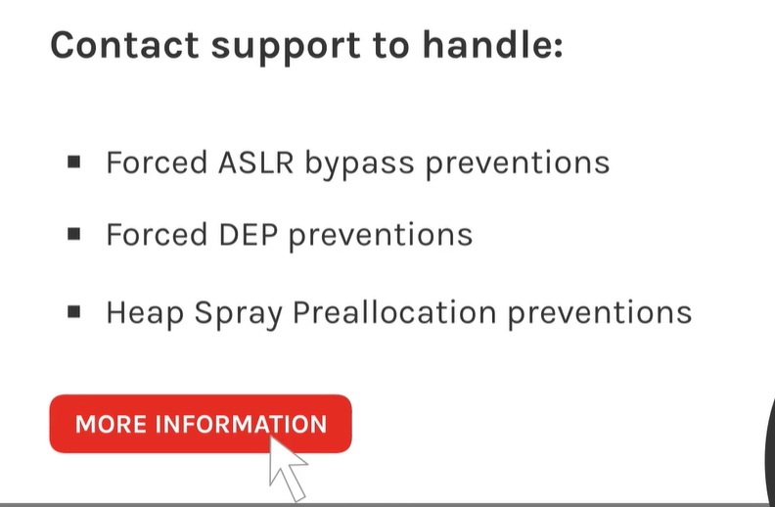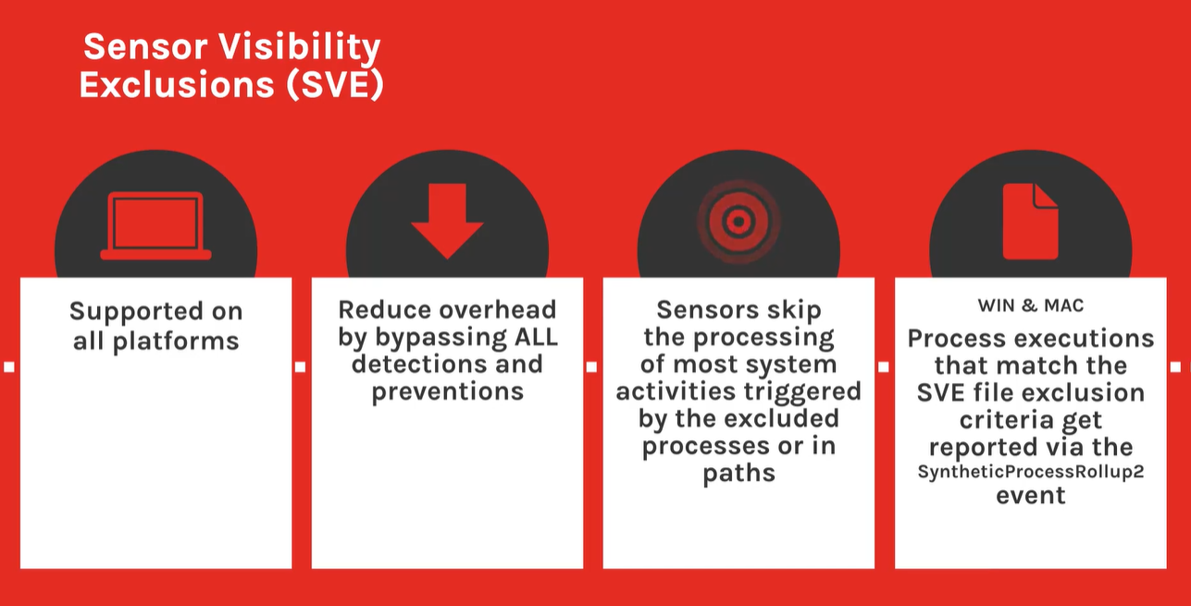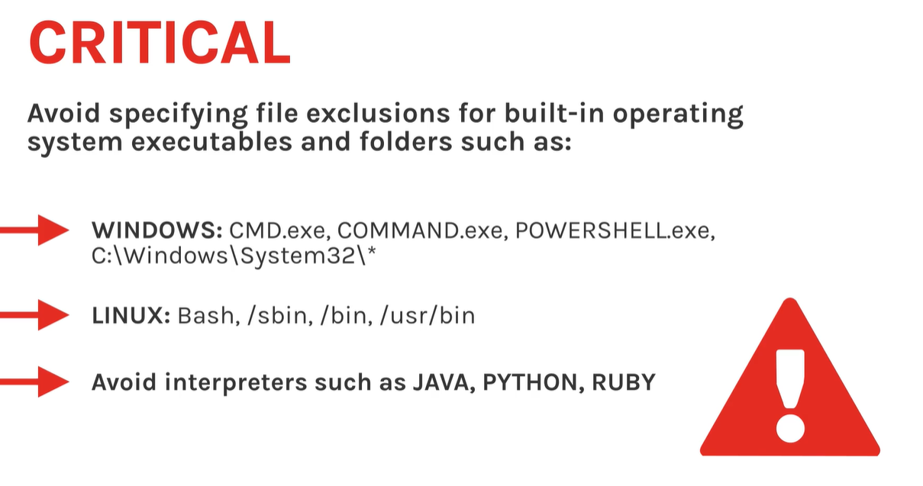

**Once you’ve confirmed that you can run the sensor on your Windows OS, you will need to make sure the following Windows services are installed and running:**

* **LMHosts**
* **Network Store Interface (NSI)**
* **Windows Base Filtering Engine (BFE)**
* **Windows Power Service (sometimes labeled Power)**

**If your Windows host is using a proxy, you will need to also make sure that WinHTTP AutoProxy is available. If you are using Web Proxy Automatic Discovery (WPAD), you’ll need to make sure that the DHCP Client is also running.**

**On Windows Server 2016 and 2019, Windows Defender is enabled by default.**

**To use Falcon’s Next-Gen Antivirus quarantine setting, you must disable Windows Defender. You can use this Powershell command to disable Defender:**

**Set-MpPreference -DisableRealtimeMonitoring $true**

**If any of these services are missing or not running, then the sensor will fail to install, and specific errors will be written to specific log files.**

**uname -r**

**The deployment guide will show all of the support kernel versions and also the minimum sensor version that must be installed for that kernel version.**

**If a kernel is not listed here, the sensor may install but will run in a Reduced Functionality Mode (RFM).**

**It will continue to operate in RFM until the Falcon sensor is updated to support that kernel version.**

**A sensor will need to be able to connect to CrowdStrike Cloud during its installation.**

**If the sensor cannot establish a connection during the installation process, the installer will attempt to reconnect after 10 minutes. If it fails again, the Sensor will uninstall from the system.**

**The Falcon sensor on your hosts uses these Fully Qualified Domain Names (FQDNs) to communicate with the CrowdStrike cloud over port 443 (outbound only, from the sensor to the CrowdStrike cloud) for everyday operation.**

**Add these FQDNs or IP addresses to your allowlists if your organization blocks these network communications.**

| **Cloud Name** | **Cloud Network address** |
| --- | --- |
| **US-1** | **ts01-b.cloudsink.net lfodown01-b.cloudsink.net** |
| **US-2** | **ts01-gyr-maverick.cloudsink.net ts01-gyr-maverick.cloudsink.net** |
| **US-GOV-1** | **ts01-laggar-gcw.cloudsink.net lfodown01-laggar-gcw.cloudsink.net** |
| **US-GOV-2** | **ts01-us-gov-2.cloudsink.crowdstrike.mil lfodown01-us-gov-2.cloudsink.crowdstrike.mil** |
| **Falcon EU Cloud** | **ts01-lanner-lion.cloudsink.net lfodown01-lanner-lion.cloudsink.net** |

**If your network requires allowlisting by IP address, instead of Fully Qualified Domain Name, see Cloud IP Addresses in the Support documentation for a list of IP addresses we use.**

**Note:  We use AWS for some communications between hosts and the CrowdStrike cloud.**

**Next, the Falcon Sensor uses certificate pinning to defend against man-in-the-middle attacks. Consequently, some network configurations that use deep packet inspections can interfere with certificate validation.**



**You will need to disable deep packet inspection or similar network configuration.  This is also referred to as: HTTPS Interception, TLS Interception, or SSL inspection.**

**Common sources for this interference can be  antivirus systems, firewalls, or proxies.**

**Lesson 1 of 5**

**Prevention Policy**



**When you install your first sensor, the sensor will be configured with a specific prevention, sensor update, and content update policies.**

**Let's go over some Prevention Policy considerations.**

**Continued**



**CrowdStrike Falcon uses overlapping methods to detect both known and unknown threats.**

**This helps ensure detection and prevention of attacks at multiple stages, and is also why enabling all of the recommended prevention policies is critical.**



**Continued**

**When you install your first sensor, it will use the settings in your default prevention policy.  As a general rule, hosts will always inherit the default policy unless the host has been assigned another prevention policy.**



**Navigate to Endpoint security > Configure > Prevention policies to check the default policy**



**Use the Platform dropdown to view the default policy for the selected operating system.**



**For new customers, we recommend a three-phase approach to configuring prevention policy settings.**

1. **Provides preliminary protection against high-risk exploits while preparing for full protection in later phases.**

**Click to flip**

1. **Front of card**

**Phase 2: Interim protection**

**Click to flip**

**Back of card**

**Delivers robust interim protection while paving the way for full enforcement in Phase 3.**

**Click to flip**

1. **Front of card**

**Phase 3: Optimal protection**

**Click to flip**

**Back of card**

**Provides comprehensive and highly secure protection, tailored to the environment through prior phase refinements.**

**This three-phase approach to deploying prevention policy settings offers a structured path from initial deployment to full realization of our best practices.**



**Leverage change control procedures to advance hosts from phase 1 settings to phase 2. Typically, it should take no more than 45 days to complete full sensor deployment to all eligible endpoints and move into phase 2 settings. It should take no more than  90 days after deployment to apply phase 3 settings to all hosts.**

**The sensor update policy will allow you to control the update process for your hosts.**

**Hosts can either auto update to the latest version of the sensor, or be assigned a specific version.**

**Like the prevention policy, hosts will inherit the default policy unless they have been assigned to a different prevention policy.**

**Sensor Update Policies features**

**With Sensor update policy you can:**

* **•**

**Lock host groups to a specific sensor versions**

* **•**

**Control whether the cloud manages sensor version updates**

* **•**

**Protect sensors from unauthorized uninstallation by end users**

* **•**

**Deploy new sensor versions to host groups for testing and validation**

**You can revert a sensor to a previous version, but only to a version released in the last 180 days. Because of our 180-day support window, we strongly recommend that you test and update to the latest sensor version as soon as possible.**

**Content update policies control how content updates are deployed to your hosts.**

**Content updates contain channel files, which deliver configuration information from the CrowdStrike cloud to Falcon sensors. These files are necessary to maintain security posture and sensor health.**

**There are several content update categories that deliver specific types of channel files. You can configure the deployment of some CrowdStrike-initiated channel files with content update policies.**

**Click on each channel file category card to review it's purpose on the back.**

**Click on each channel file category card to review it's purpose on the back.**

1. **Front of card**

**System Critical**

**Click to flip**

**Back of card**

**Required by the Falcon sensor for ongoing operating system stability.**

**Click to flip**

1. **Front of card**

**Sensor Operations**

**Click to flip**

**Back of card**

**Ensure the Falcon sensor’s compatibility in response to vendor-provided operating system kernel updates for Windows and Linux.**

**Click to flip**

1. **Front of card**

**Vulnerability Management**

**Click to flip**

**Back of card**

**Provide the sensor with vulnerability definitions and data.**

1. **Provide false positive/false negative mitigation updates for Indicator Of Attack and Machine Learning content.**

**Click to flip**

1. **Front of card**

**Rapid Response - Behavioral IOAs**

**Click to flip**

**Back of card**

**Provide behavioral IOAs as well as telemetry, detection, and prevention logic to the Falcon sensor on an ongoing basis.**

**Click to flip**

1. **Front of card**

**Customer-initiated channel files**

**Click to flip**

**Back of card**

**Customer-defined policies for Falcon modules based on the configurations made using the Falcon console or APIs.**

**Click to flip**

**Content update deployment options**

**You can configure these deployment options:**

**Click on the plus sign to review the information inside.**

**General availability (GA) (strongly recommended)**

**Receive content updates during general availability. General availability (GA) is a phased rollout after a successful deployment to hosts in early access.**

**GA +4 hours**

**Receive content updates 4 hours after general availability deployment completes.**

**Early access**

**Receive content updates following successful internal testing and deployment to all CrowdStrike assets. Early Access content has been fully tested by CrowdStrike and is considered stable and ready for production.**

**Pause (not recommended)**

**Your sensor won’t receive content updates. The Pause option affects sensor performance in these ways:**

* **If Sensor Operations channel files are paused, your sensors won't receive sensor configuration updates, which will impact operating system and application compatibility and may lead to reduced functionality mode (RFM) on Windows and Linux hosts.**
* **If Rapid Response - Allowlisting and Blocklisting channel files are paused, your sensors won’t receive allowlisting and blocklisting updates generated by CrowdStrike threat researchers and analysts.**
* **If Vulnerability Management channel files are paused, your sensors won’t receive updated vulnerability definitions and data.**

**Important: This option isn’t available for System Critical channel files.**

**You can create Fusion SOAR workflows to send notification settings when a content update policy is created, edited, or deleted.**

**You can also create a scheduled workflow with Falcon Fusion SOAR to automatically set content update settings for a policy. This feature helps you pause or enable content updates during a specified time frame. Please refer to the Fusion SOAR training for the details.**

**The Windows sensor file itself is an executable that can either be launched as a manual install or run as an automated command-line install.**

**To ensure that sensors function as expected, don’t shut down or reboot the host while the sensor is being installed. Doing so can cause the host to repeatedly crash on boot or omit the uninstall option.**

**Step 1**

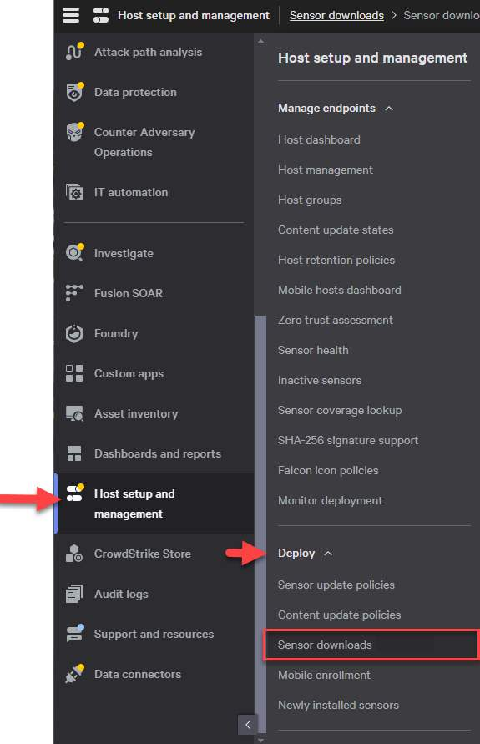

**Download the sensor installer from Host setup and management > Deploy > Sensor downloads.**

**Step 2**

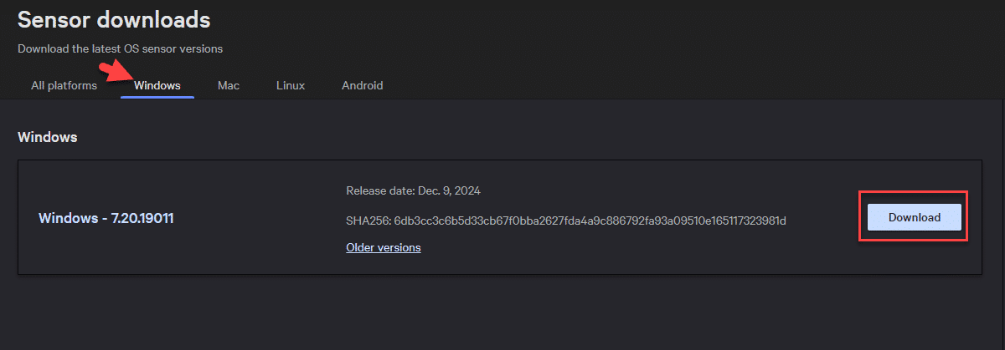

**Locate the sensor installer for your operating system by selecting the appropriate tab and click Download.**

**Step 3**

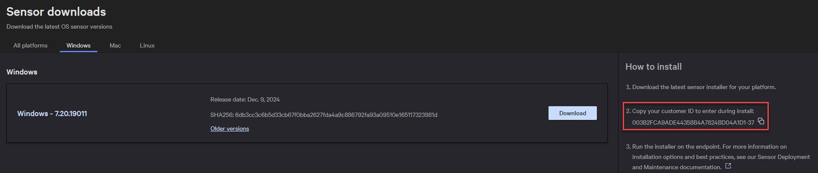

**Copy your customer ID checksum (CCID) from Host setup and management > Deploy > Sensor downloads.**

**If you’re a trial user, skip this step.**

**Step 4**

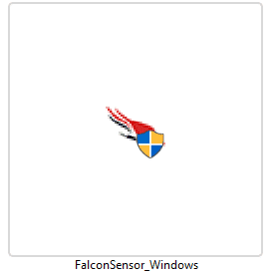

**Copy the sensor installer to the endpoint and double-click the installer.**

**Step 5**

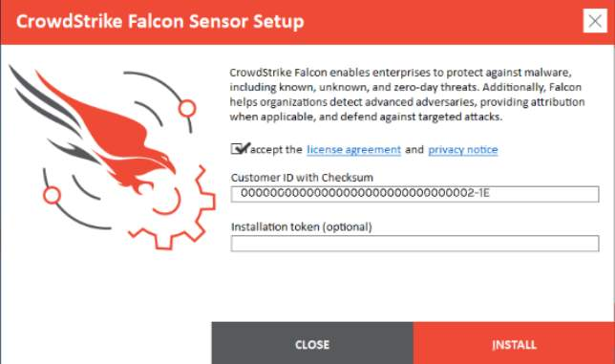

**Accept the license agreement and enter your customer ID checksum.**

**If you're a trial user, skip this step.**

**Step 6**

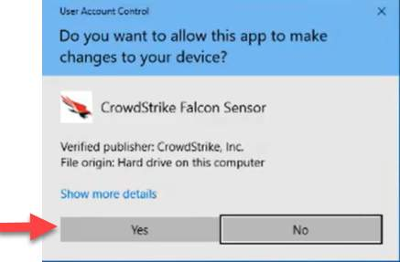

**If your OS prompts to allow the installation, click Yes.**

**Step 7**

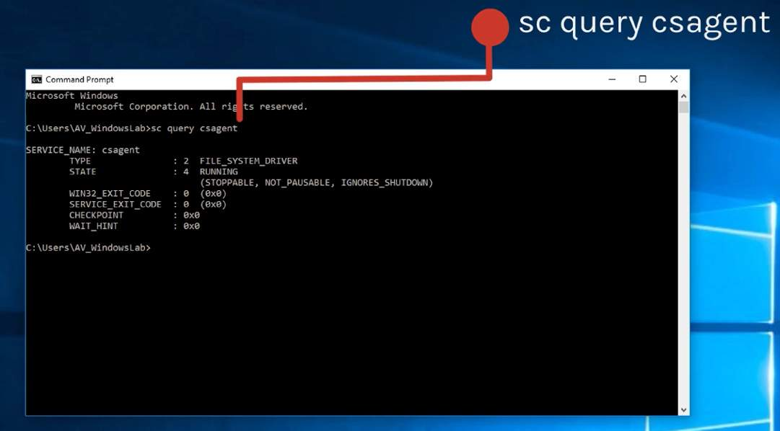

**After installation, the sensor will run silently and will be invisible to the user.**

**To validate that the sensor is running on the host, run this command in a command prompt: sc.exe query csagent**

**The output shown in the image will appear if the sensor is running.**

**Summary**

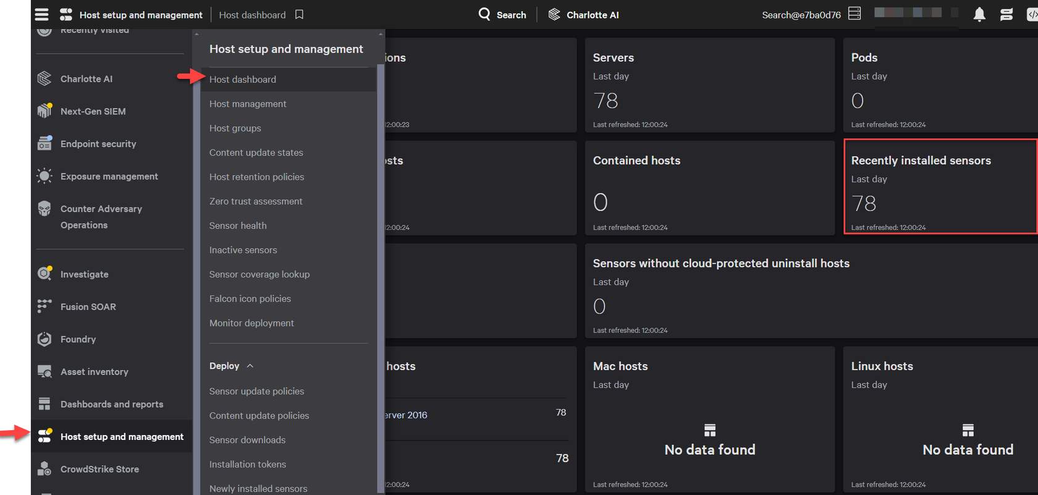

**If the output is different, then we will need to go into some troubleshooting steps.  We will cover that later on in this course.**

**You can also log into the Falcon Interface to confirm that this host is now being seen.**

1. **From the main menu in Falcon, navigate to Host setup and management**
2. **Click on Host Dashboards under Manage Endpoints**

**You should see a number in the recently installed box. You can click on this for more details and you should see the most recently installed host.**

**Automatic installation**

**Use the arrows to review the Automatic installation steps.**

**Step 1**



**Download the sensor installer from Host setup and management > Deploy > Sensor downloads.**

**Step 2**



**Locate the sensor installer for your operating system by selecting the appropriate tab and click Download.**

**Step 3**



**Copy your customer ID (CCID) from Host setup and management > Deploy > Sensor downloads.**

**If you’re a trial user, skip this step.**

**Step 4**

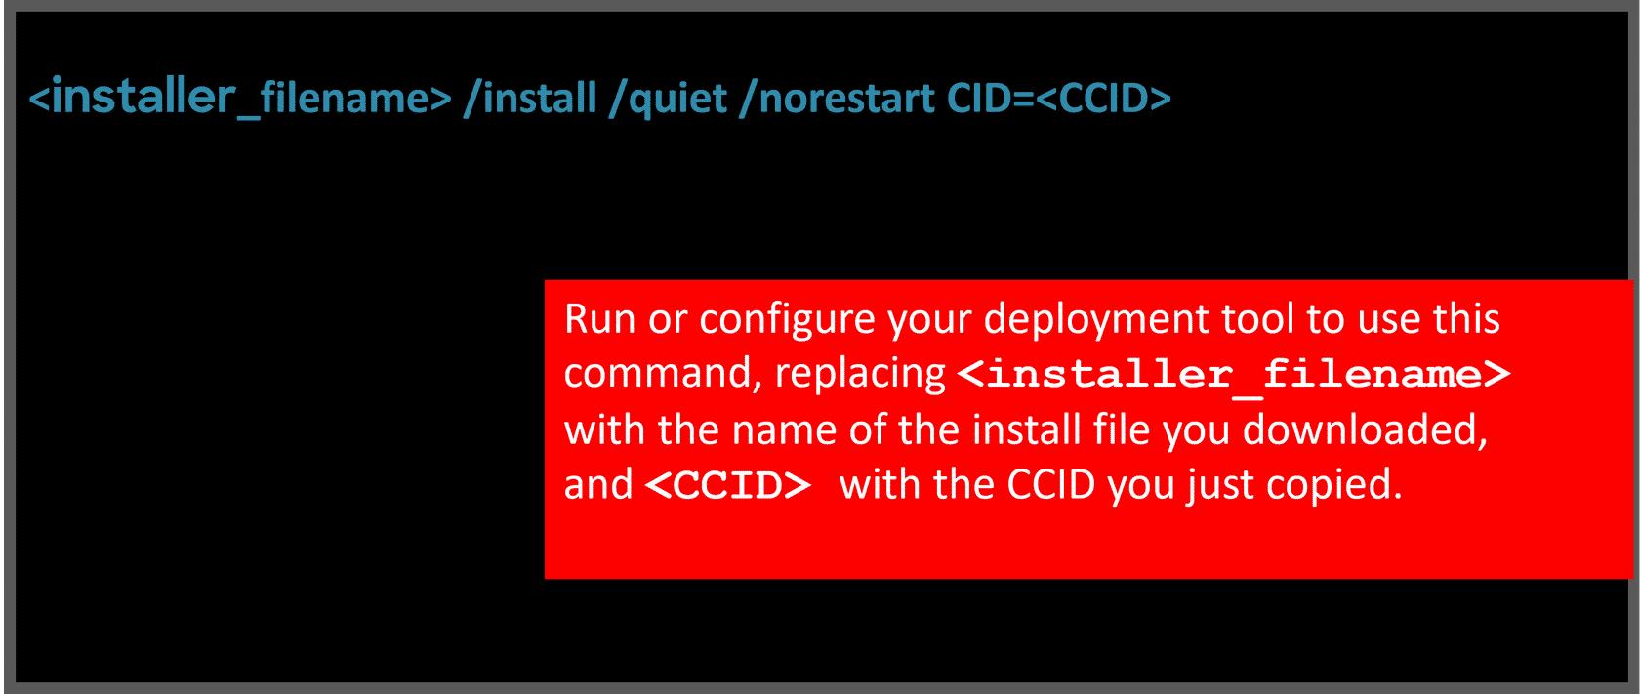

**Run or configure your deployment tool to use this command, replacing <installer_filename> with the name of the install file you downloaded, and <CCID> with the CCID you just copied <installer_filename> /install /quiet /norestart CID=<CCID>**

**Step 5**

**Once you launch this command line, all of the sensor files will get installed, including all of your policy information.**

**The sensor will then start and an AID will be assigned to this host.**

**Step 6**

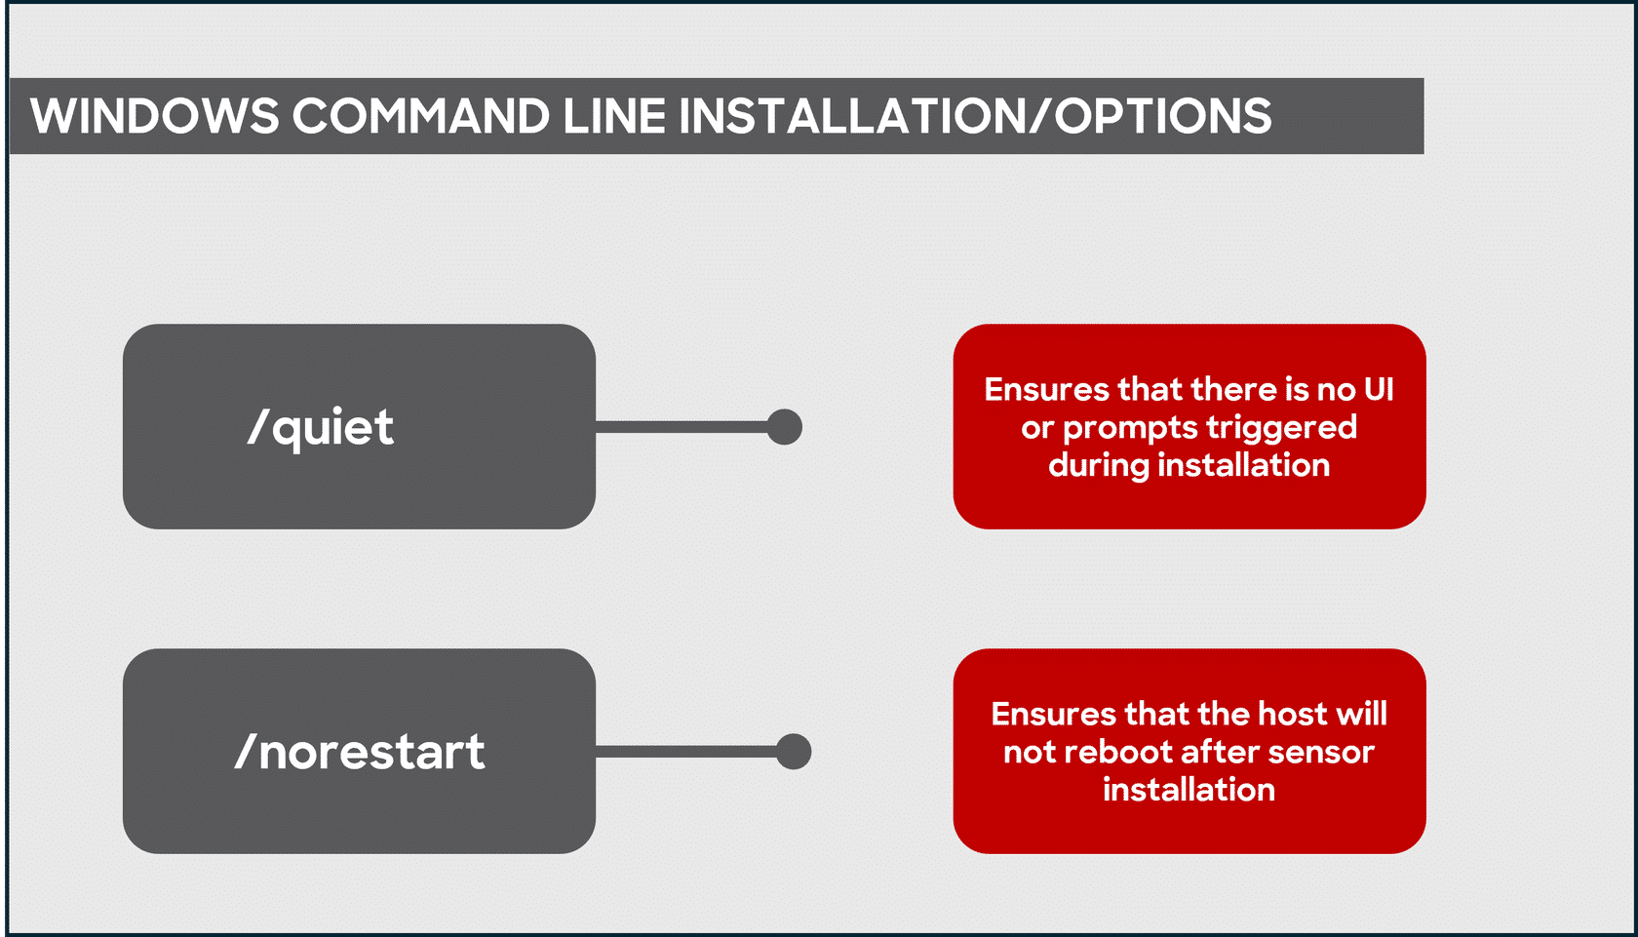

**You will want to note that all installer parameters are case-sensitive and some require a leading slash, while others may not.**

**The /quiet parameter will ensure that no UI or prompts are triggered during installation.  The /norestart parameter will ensure that the host will not reboot after sensor installation.**

**Summary**

**There are some additional parameters that you will need to consider depending on your deployment strategy.**

**We will cover these in the next section.**

**Assigning Sensor Tags During Windows Installation**

**The Falcon platform allows you to assign metadata to your hosts in the form of sensor tags. Sensor grouping tags are optional.**



**These tags enable you to categorize your sensor-enabled hosts by location, environment purposes, or any other criteria you deem fit.**

**You can assign one or more tags to a host using the GROUPING_TAGS parameter during installation. Assigning tags at this point makes them immediately available when the sensor first connects to the CrowdStrike cloud.**

**Tags are case-sensitive. To use multiple tags, separate tags with commas. The combined length of all tags for a host, including comma separators, cannot exceed 256 characters.**

|  |  |
| --- | --- |
| **Tags can include these characters** | **Tags can't include these characters** |
| **Letters (a-z, A-Z)** | **Spaces ()** |
| **Numbers (0-9)** | **Commas (,)** |
| **Hyphens (-)** |  |
| **Underscores (_)** |  |
| **Forward slashes (/)** |  |

**This following command assigns two tags to the host: Washington/DC_USA and Production.**

|  |
| --- |
| **<installer_filename> /install /norestart CID=<CCID> GROUPING_TAGS="Washington/DC_USA,Production"** |

**Replace <installer_filename> with the name of the install file you downloaded, and <CCID> with the CCID from Host setup and management > Deploy > Sensor downloads.**

**Viewing a host's sensor grouping tags**

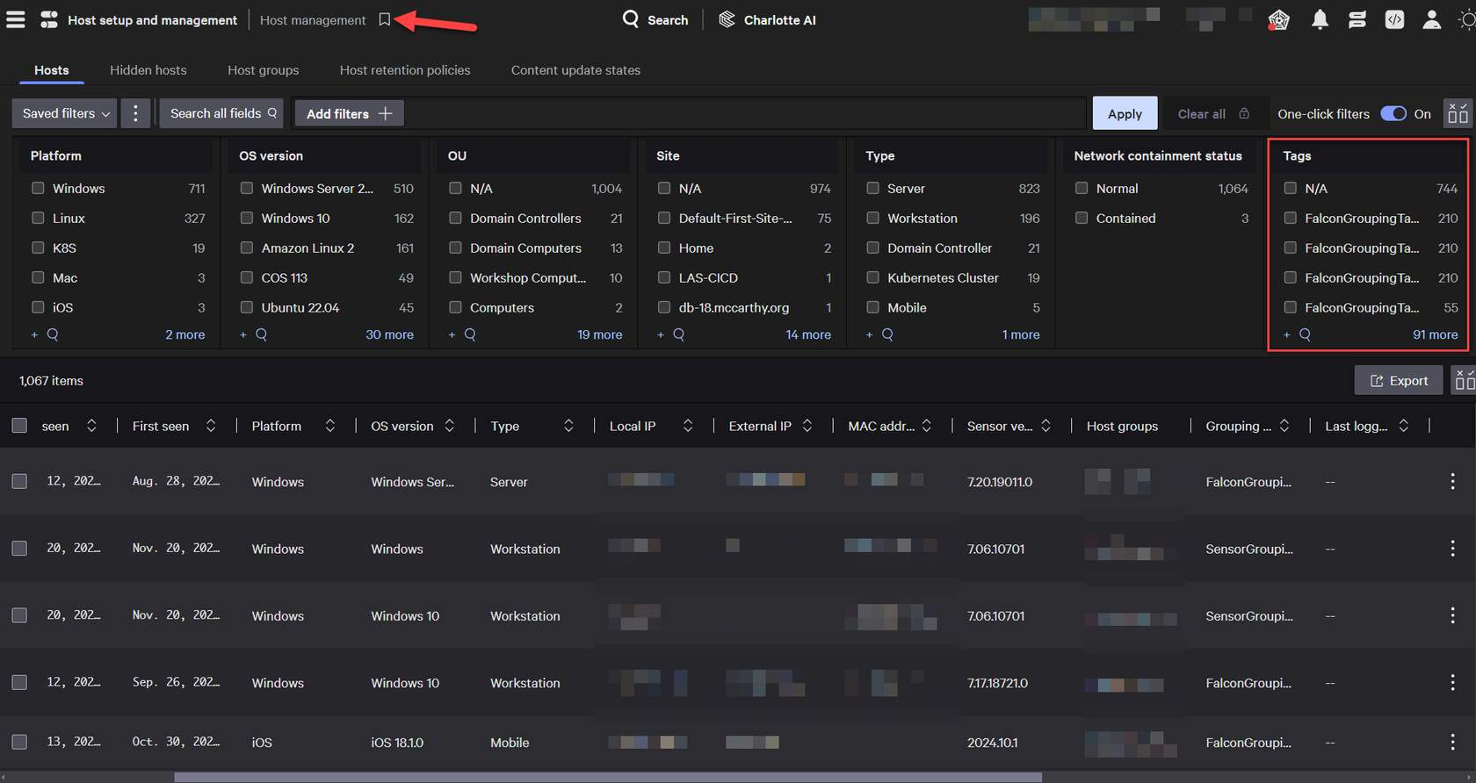

**To confirm that the tags are visible in the Falcon interface, visit the Host management page. Filter by tags and your list of tags will appear in the dropdown.**

**After sensor installation, the way you add or remove tags depends on your sensor version.**

**Sensor Tags are optional, and a great way to organize your hosts!**

**Uninstalling the Falcon sensor for Windows**



**To uninstall a sensor, you can use the Control Panel or the command line.**

**Click on the plus sign to review the information inside.**

**Uninstalling using the Control Panel**

1. **Open the Windows Control Panel running it as administrator.**
2. **Click Uninstall a Program.**
3. **Choose CrowdStrike Windows Sensor and uninstall it, providing the maintenance token through the installer if necessary.**

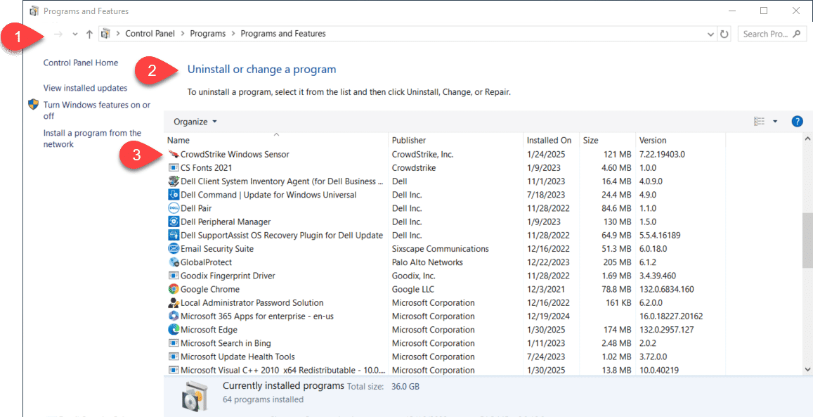

**Uninstalling using the command line**

1. **Download Falcon Windows Sensor, Uninstall Tool from**[**Tool Downloads(opens in a new tab)**](https://falcon.crowdstrike.com/support/tool-downloads)
2. **Open a command prompt with administrative privileges and run this command: CsUninstallTool.exe /quiet**

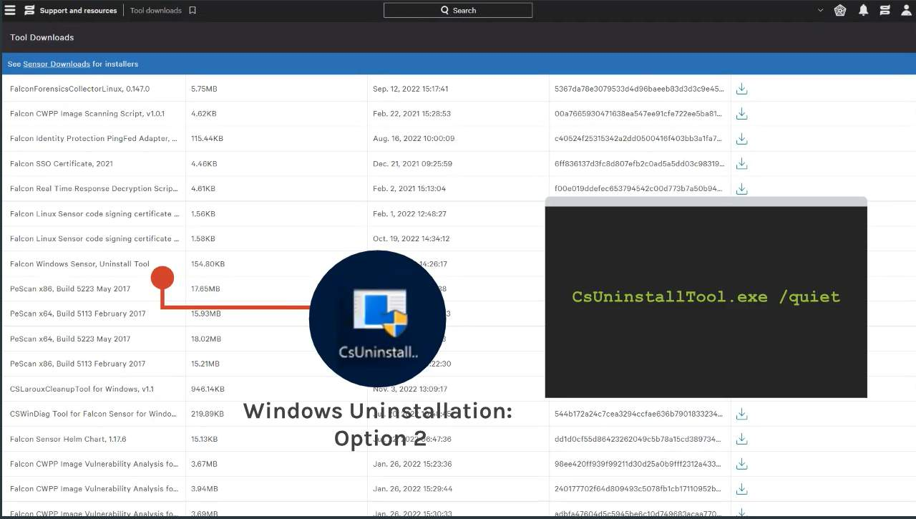

**Validating the uninstallation**

**When the sensor has been uninstalled:**

* **The sensor does not appear in your programs list**
* **The directory C:\Windows\System32\drivers\CrowdStrike is not present**
* **The registry key HKLM\System\Crowdstrike does not appear in the registry**

**Uninstall protection cases**

**If uninstall protection is enabled, you must complete additional steps. Let's look at some cases for this.**

**Navigate through all three tabs below to review protection cases.**

**Case 1**

**Sensor is online**

**Move the host into a sensor update policy with Uninstall and maintenance protection disabled, then uninstall using one of the two uninstall methods.**

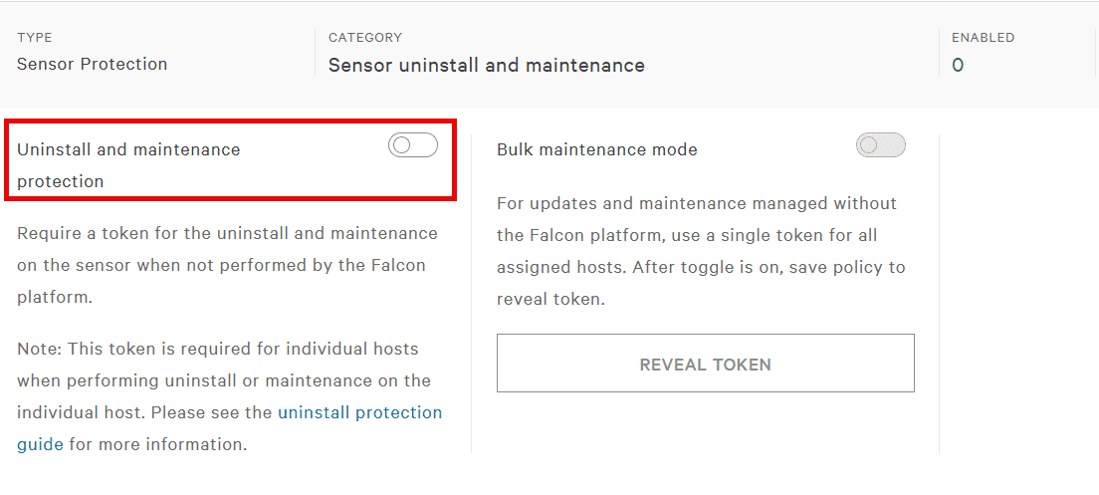

**Case 2**

**Sensor is offline and "Uninstall and maintenance protection" is enabled**

* **Open the host's summary panel in Hosts > Host Management page and click Reveal Maintenance Token from the Actions to get the single-use maintenance token needed to uninstall the sensor.**
* **Use this token in this command line script to uninstall the sensor:  
  CsUninstallTool.exe MAINTENANCE_TOKEN=<token> /quiet**

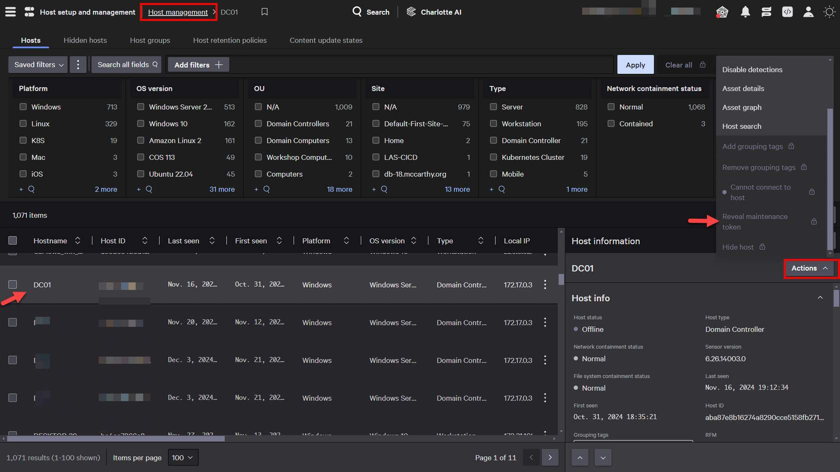

**Case3**

**Sensor is offline and bulk maintenance mode is enabled**

* **Go to the host's sensor update policy and click Reveal Token to get the bulk maintenance token needed to uninstall the sensor.**
* **Use the token in this command line script to uninstall the sensor:  
  CsUninstallTool.exe MAINTENANCE_TOKEN=<token> /quiet**

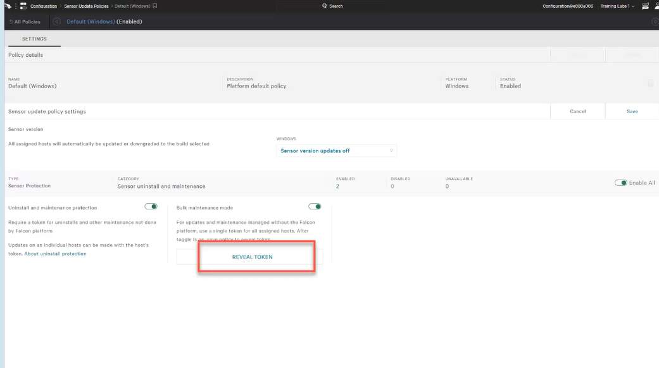

**CONTINUE**